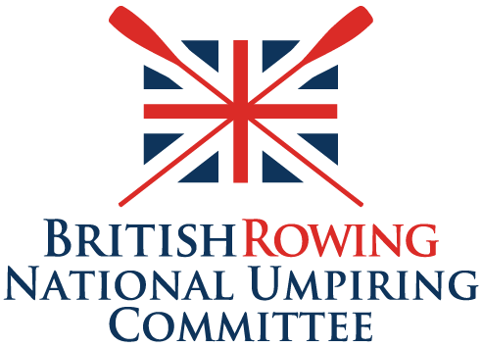
APPLICATION FOR RENEWAL OF UMPIRE’S LICENCE

Please complete the following information, including the declaration, and then send this form to your Regional Umpiring Committee Chair for authorisation.

Name
Telephone
Email
Club (if any)
Region
BR Membership Number |  | Expiry Date (dd/mm/yyyy)
I have completed the online Rules of Racing module since 1 Sept. of the current year |  |  | Yes/No
I have a current British Rowing Membership: Race, Row, Coach or Support  (excluding ‘Scottish & Overseas’ and ‘Friend of British Rowing’ memberships) |  |  | Yes/No
I have included a record of my umpiring activities (see final page) |  |  | Yes/No

Please read the declaration before completing the form
I confirm I am over the age of 18. I understand that this information will be used by British Rowing and will be shared with the umpiring committees.
I acknowledge I have a duty of care to competitors, colleagues, and the general public. I declare myself capable and competent to undertake all duties and activities required of me as an umpire *. In the event of a material change I will inform my RUC Chair immediately.
Signed **
Date

British Rowing's Privacy Policy can be accessed at: https://www.britishrowing.org/privacy-policy-and-cookies-policy/.
* These may include but are not limited to accessing umpiring positions from a launch or scaffold tower, being exposed to inclement weather, standing or walking for long periods of time, assisting distressed or capsized competitors.
** This process can be done electronically. Receipt of renewal forms from the RUC Chair’s email address, or from that of a designated RUC member, will suffice instead of written signatures. There is no need to print this document out to sign it and then scan it back in again.
For Regional Umpiring Committee Use

Indicate the recommended course of action
It is recommended this licence is renewed for three years
It is recommended this licence is renewed for one year
It is recommended that this licence is withdrawn
Remarks
Please add details if necessary, to support the course of action indicated above
Signed
RUC Chair **
Region
Date

** This process can be done electronically. Receipt of renewal forms via the RUC Chair’s email address, or from that of a designated RUC member, will suffice instead of written signatures. There is no need to print this document out to sign it and then scan it back in again.

When complete this form should be emailed to the NUC Secretary.
Please provide details of your British Rowing umpiring activities for the past three years. You can either complete the following tables or send in the information separately if you maintain a list of your seminars and other umpiring activities in a different format. If that is the case this page can be deleted.
British Rowing domestic seminars attended in the past three years.
Date  dd/mm/yyyy | Venue | Type  (e.g. Regional, Multi-Lane)
e.g. 04/11/2021 | Insert location | Regional
British Rowing competitions at which I have officiated as an umpire, or trainee umpire, in the past three years.
Please list competitions in chronological order and provide the full details as shown in the example.
Date  dd/mm/yyyy | Competition | Capacity  Including roles e.g. Starter, Finish Judge
e.g. 01/04/2021 | BR Masters Championships | Control Commission Weighing, Chief Finish Judge, Launch Umpire
Use a continuation sheet if required

